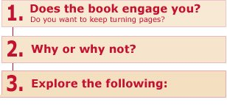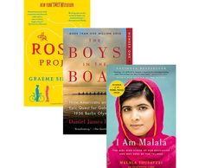[**How to Read-Think-Talk (about a book)**](http://www.litlovers.com/run-a-book-club/read-think-talk)

|  |  |
| --- | --- |
|  | readthinktalk_charact  • Are the characters **convincing**? Do they come alive for you? How would you describe them — as sympathetic, likeable, thoughtful, intelligent, innocent, naive, strong or weak? Something else?  • Do you **identify** with any characters? Are you able to look at events in the book through their eyes—even if you don’t like or approve of them? Do they remind you of people in your own life? Or yourself?  • Are characters **developed** psychologically and emotionally? Do you have access to their inner thoughts and motivations? Or do you know them mostly through dialogue and action?  • Do any characters **change or grow** by the end of the story? Do they come to view the world and their relationship to it differently?  readthinktalk_plot  • Is the story **plot-driven**, moving briskly from event to event? Or is it character-driven, moving more slowly, delving into characters' inner-lives?  • What is the story’s **central conflict—**character vs. character...vs. society...or vs. nature (external)? Or an emotional struggle within the character (internal)? How does the conflict create tension?  • Is the plot **chronological**? Or does it veer back and forth between past and present?  • Is the **ending** a surprise or predictable? Does the end unfold naturally? Or is it forced, heavy handed, or manipulative? Is the ending satisfying, or would you prefer a different ending?  readthinktalk_point  • Who **tells the story**—a character (1st-person narrator)? Or an unidentified voice outside the story (3rd-person narrator)? Does one person narrate—or are there shifting points of view?  • What does the narrator **know**? Is the narrator privvy to the inner-life of one or more of the characters...or none? What does the narrator let you know?  readthinktalk_imagin  • What about **theme**—the larger meanings behind the work? What ideas does the author explore? What is he or she trying to say?  • **Symbols** intensify meaning. Can you identify any in the book—people, actions or objects that stand for something greater than themselves?  • What about **irony**—a different outcome, or reality, than expected. Irony mimics real life: the opposite happens from what we desire or intend...unintended consequences. |